#1 Show number of appointments by a clinic, by year, by month and display values on the UI

http://localhost:61304/Appointment

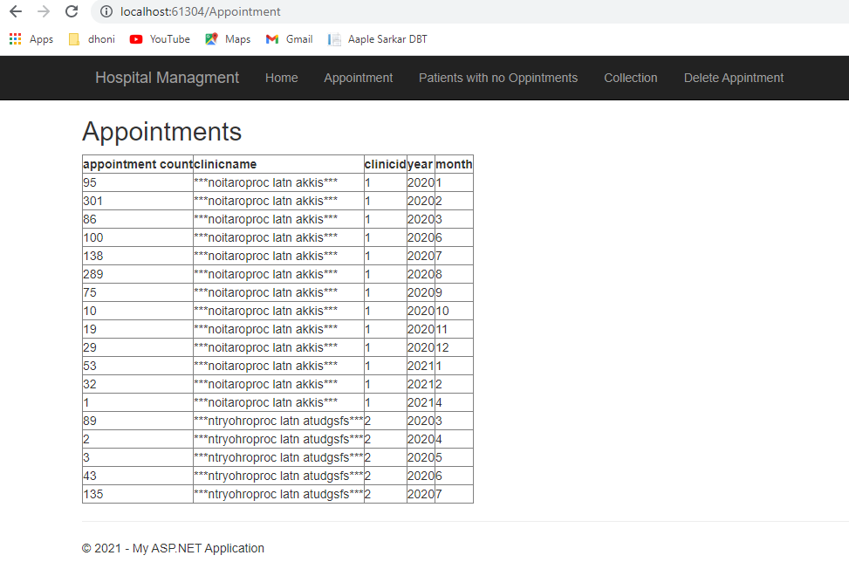

#2 Show a list of patients with patient details who do not have appointments in the future. Display a

table on UI.

http://localhost:61304/PaitentNoOpps

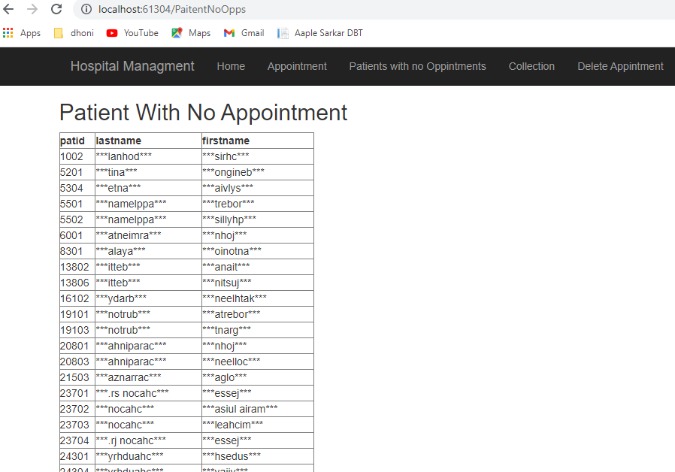

#3 Calculate the age of the patient from birthdate and update it into the table. Update patientagegroup

column based on a following condition - if age is less than 18 then Minor and other Adult.

Please refer SQL script 3 Update age and patientagegroup from Hospitalmanagment\Dataserver\Stored Procedure

#4 Display on UI in tabular format. Total production, Payments, Production Adjustments, Collection

Adjustments by clinic name by Provider name by year by month.

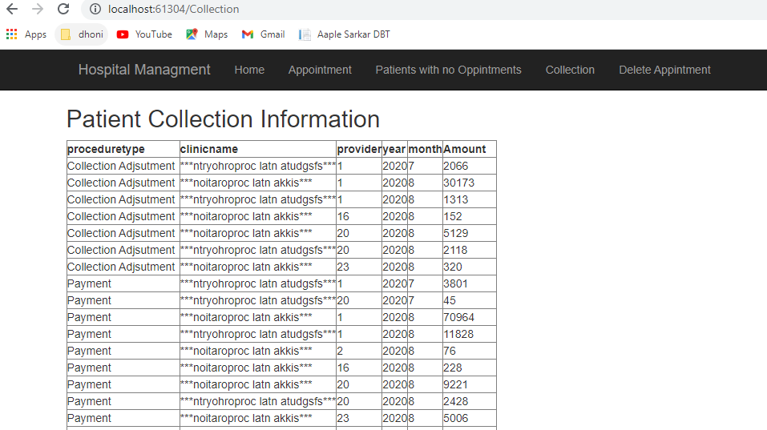

#5 Add functionality to delete appointment having amount less than 50

User need to enter amount to delete appointment

http://localhost:61304/DeleteAppointment

